

BIOLOGY

UNITS 1 & 2

2021

Name: ___________

Teacher: ___________

Time allowed for this paper
Reading time before commencing work: ten minutes
Working time: three hours

Materials required/recommended for this paper
To be provided by the supervisor
This Question/Answer booklet
Multiple-choice answer sheet

To be provided by the candidate
Standard items: pens (blue/black preferred), pencils (including coloured), sharpener, correction fluid/tape, eraser, ruler, highlighters
Special items: non-programmable calculators approved for use in this examination

Important note to candidates
No other items may be taken into the examination room. It is your responsibility to ensure that
you do not have any unauthorised material. If you have any unauthorised material with you, hand
it to the supervisor before reading any further.

Structure of this paper

Section | Number of questions available | Number of questions to be answered | Suggested working time (minutes) | Marks available | Percentage of examination
Section One  Multiple-choice | 30 | 30 | 40 | 30 | 30
Section Two  Short answer | 5 | 5 | 90 | 100 | 50
Section Three  Extended answer  Unit 1 | 2 | 1 | 50 | 40 | 20
Unit 2 | 2 | 1
 |  |  |  | Total | 100

Instructions to candidates

1. The rules for the conduct of the Western Australian external examinations are detailed in the Year 12 Information Handbook 2021. Sitting this examination implies that you agree to abide by these rules.

2. Write your answers in this Question/Answer booklet preferably using a blue/black pen. Do not use erasable or gel pens.

3. Answer the questions according to the following instructions.

Section One: Answer all questions on the separate Multiple-choice answer sheet provided. For each question, shade the box to indicate your answer. Use only a blue or black pen to shade the boxes. Do not use erasable or gel pens. If you make a mistake, place a cross through that square, then shade your new answer. Do not erase or use correction fluid/tape. Marks will not be deducted for incorrect answers. No marks will be given if more than one answer is completed for any question.

Section Two: Write your answers in this Question/Answer booklet. Wherever possible, confine your answers to the line spaces provided.

Section Three: Consists of two parts each with two questions. You must answer one question from each part. Tick the box next to the question you are answering. Write your answers in this Question/Answer booklet.

4. You must be careful to confine your answers to the specific questions asked and to follow any instructions that are specific to a particular question.

5. Supplementary pages for planning/continuing your answers to questions are provided at the end of this Question/Answer booklet. If you use these pages to continue an answer, indicate at the original answer where the answer is continued, i.e. give the page number.

Section One: Multiple-choice 30% (30 Marks)

This section has 30 questions. Answer all questions on the separate Multiple-choice answer sheet provided. For each question, shade a box to indicate your answer. Use only a blue or black pen to shade the boxes. If you make a mistake, place a cross through that square, then shade your new answer. Do not erase or use correction fluid/tape. Marks will not be deducted for incorrect answers. No marks will be given if more than one answer is completed for any question.

Suggested working time: 40 minutes.

- A biological population is best described as

- a group of organisms in a particular geographic area.
- a group of organisms in a particular area that share the same biological niche.
- a group of organisms in a particular area that can potentially interbreed.
- a group of organisms that interact with one another in the same location.

- A zoologist was examining the partial remains of a recently deceased mammal. Upon close inspection the mammal was found to have a short alimentary canal with a small caecum, and a single stomach with contents of a low pH. The zoologist would conclude that this mammal was most likely a
- herbivore.
- keystone species.
- carnivore.
- first order consumer.

- Biodiversity can be classified at three levels. These levels are

- genes, species and ecosystems.
- species, populations and ecosystems.
- cells, tissues and systems.
- genes, individuals and biomes.

- A student uses a microscope with a 10X ocular and 10X objective. With this lens combination, the microscope has a field of view of 2.8mm. What will be the field of view if the student moves the 40X objective into position?

- 0.28mm.
- 2.8mm.
- 28mm.
- None of the above.

- The process by which a toxin becomes more concentrated in the tissues of organisms with each higher trophic level is known as

- biosequestration.
- biomagnification.
- bioconcentration.
- bioamalgamation.

Question 6 relates to the image below.

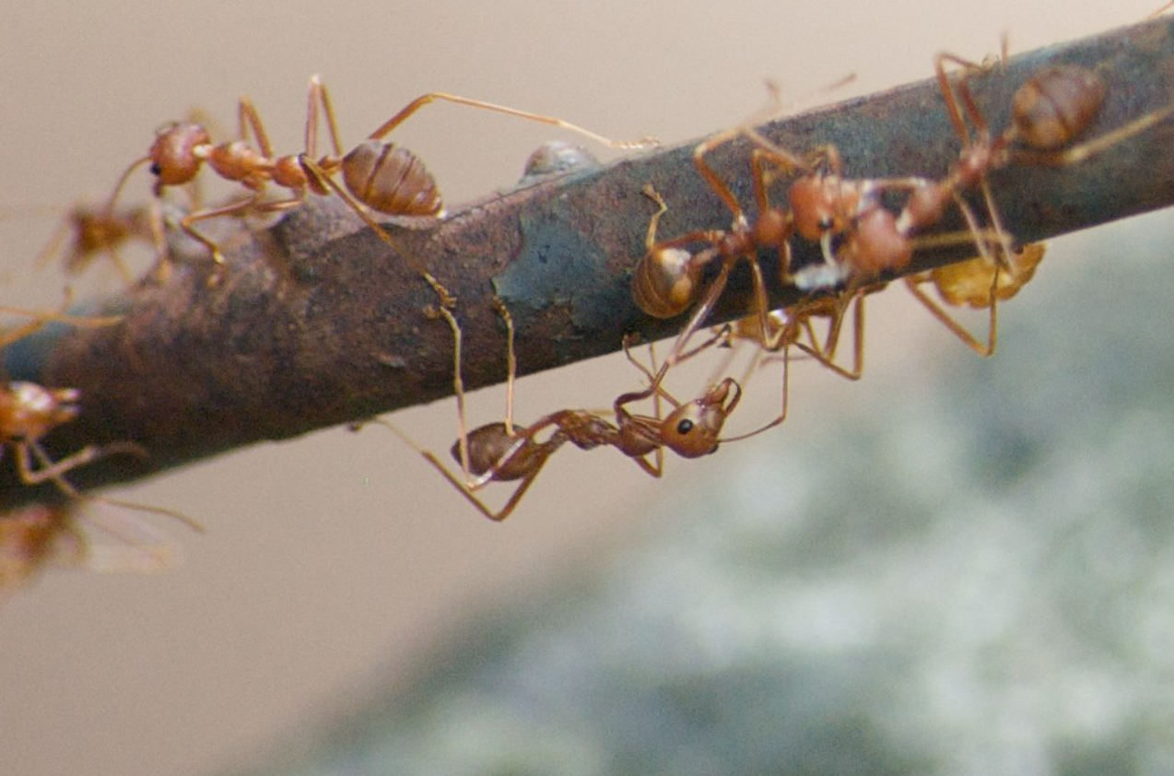

- Red fire ants are an invasive, omnivorous species that have been introduced to Queensland from South America. Through which of the following food chains will the ants gain the most available energy resources?
- Plant ants.
- Plant caterpillar ants.
- Plant caterpillar bird ants.
- Plant caterpillar bird quoll ants.

- A biochemist is conducting a nutritional analysis of traditional foods eaten by aboriginal people. Bogong moths (Agrotis infusa) were once a major seasonal food source for people in the New South Wales Southern Highlands. The biochemist found that approximately 35% of Bogong moth weight is composed of substances containing glycerol. These substances are classified as

- lipids.
- carbohydrates.
- proteins.
- glycogen.

- Why do mice have higher metabolic rates than elephants?

- Elephants have a relatively high surface area to volume ratio, thus losing heat slower per unit of volume than mice.
- Mice have a relatively high surface area to volume ratio, thus losing heat slower per unit of volume than elephants.
- Elephants have a relatively low surface area to volume ratio, thus losing heat slower per unit of volume than mice.
- Mice have a relatively high surface area to volume ratio, thus losing heat slower per unit of volume than elephants.

- Which of the following allows for efficient gas exchange in plants?
- loosely packed spongy mesophyll cells.
- a waxy cuticle on the upper side of leaves.
- stomata sunken in pits.
- dense vascular bundles.

Questions 10 to 12 refer to the illustration of the Paramecium below.
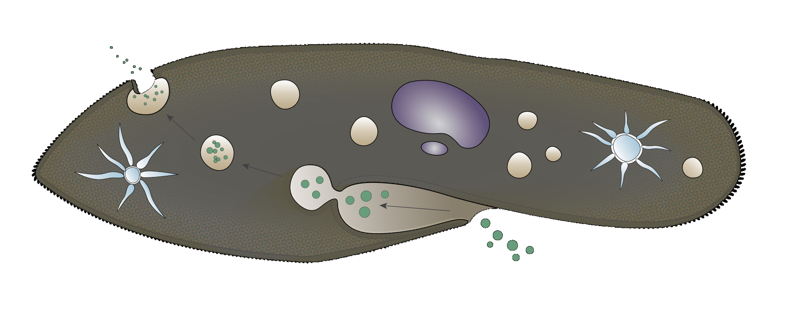
Oral groove
Nucleus
Anal pore
Contractile vacuoles

The Paramecium is a unicellular organism commonly found in freshwater and brackish environments. Paramecia use cilia to sweep microorganisms such as bacteria and algae into an oral groove. This food is encapsuled in vacuoles and digested. The remaining waste products are expelled via an anal pore.

- The process indicated in the diagram where waste is expelled from the anal pore is best described as

- exocytosis.
- endocytosis.
- facilitated diffusion.
- osmosis.

- Paramecium would best be classified as

- bacteria.
- prokaryotes.
- producers.
- eukaryotes.

- Paramecium have an organelle known as a contractile vacuole which pumps excess water out of the cytoplasm. The higher the rate of water entering the cell due to osmosis, the higher the rate the contractile vacuole will contract to expel water. Which situation would result in a high rate of contractile vacuole contraction?

- A paramecium moving from a 9.0 g/L NaCl solution to a 23 g/L NaCl solution.
- A paramecium moving from a 12.0 g/L NaCl solution to a 24 g/L NaCl solution.
- A paramecium moving from a 7 g/L NaCl solution to a 1.0 g/L NaCl solution.
- A paramecium moving from a 7 g/L NaCl solution to a 5.0 g/L NaCl solution.
- Which adaptation would decrease water loss from a plant living in an arid environment?

- Deep tap roots.
- Stomata located in pits.
- Reduced leaf hairs.
- Broad leaves.

- Which of the following statements opposes the morphological definition of ‘species’?

- A mule is the infertile offspring of a male donkey (Equus asinus) and a female horse (Equus caballus).
- Various breeds of domestic dogs (Canis familiaris) including the Labrador and the Greyhound can interbreed to produce fertile, viable offspring.
- Two species of rod-shaped bacteria (Bacillus anthracis and Bacillus fusiformis) reproduce asexually by the process of binary fission.
- Cheetah (Acinonyx jubatus) have very low genetic diversity due to severe interbreeding.

Question 15 relates to the cladogram below.
Birds
Crocodiles
Rabbits
Primates
Sharks
Bony fish
Amphibians

Eggs with shells

Amniotic egg

Four limbs

Bony skeleton

Vertebral column

- The cladogram indicates that

- rabbits and birds are more closely related than amphibians and crocodiles.
- amphibians have a bony skeleton and possess amniotic eggs.
- rabbits and bony fish do not share a common ancestor.
- there are more species with amniotic eggs than species with four limbs.

- Vascular plant species move carbohydrates through their bodies in a process known as translocation. This is achieved by

- moving sucrose through the xylem tissue.
- moving starch through the xylem tissue.
- moving sucrose through the phloem tissue.
- moving starch through the phloem tissue.

Questions 17 and 18 relate to the investigation detailed below:

A plant physiologist was investigating the effect of light intensity on the rate of photosynthesis in an aquatic species of Elodea. The investigation was run with a controlled optimum aquatic temperature of 42ºC.

Graph 1  Rate of Photosynthesis  Light intensity | Graph 2  Rate of Photosynthesis  Light intensity
Graph 3  Rate of Photosynthesis  Light intensity | Graph 4  Rate of Photosynthesis  Light intensity

- Which of the graphs below best illustrates the relationship between light intensity and the rate of photosynthesis in Elodea?

- Graph 1
- Graph 2
- Graph 3
- Graph 4

- When exposed to intense light, the limiting factor for photosynthesis for Elodea in this investigation would be

- light.
- carbon dioxide.
- heat.
- oxygen.

- Which of the following statements regarding the products of anaerobic respiration is correct?

- Plants and yeasts produce carbon dioxide and alcohol.
- Plants and yeasts produce oxygen and glucose.
- Animals produce lactic acid and alcohol.
- Animals produce carbon dioxide and water.

Question 20 refers to the images below.

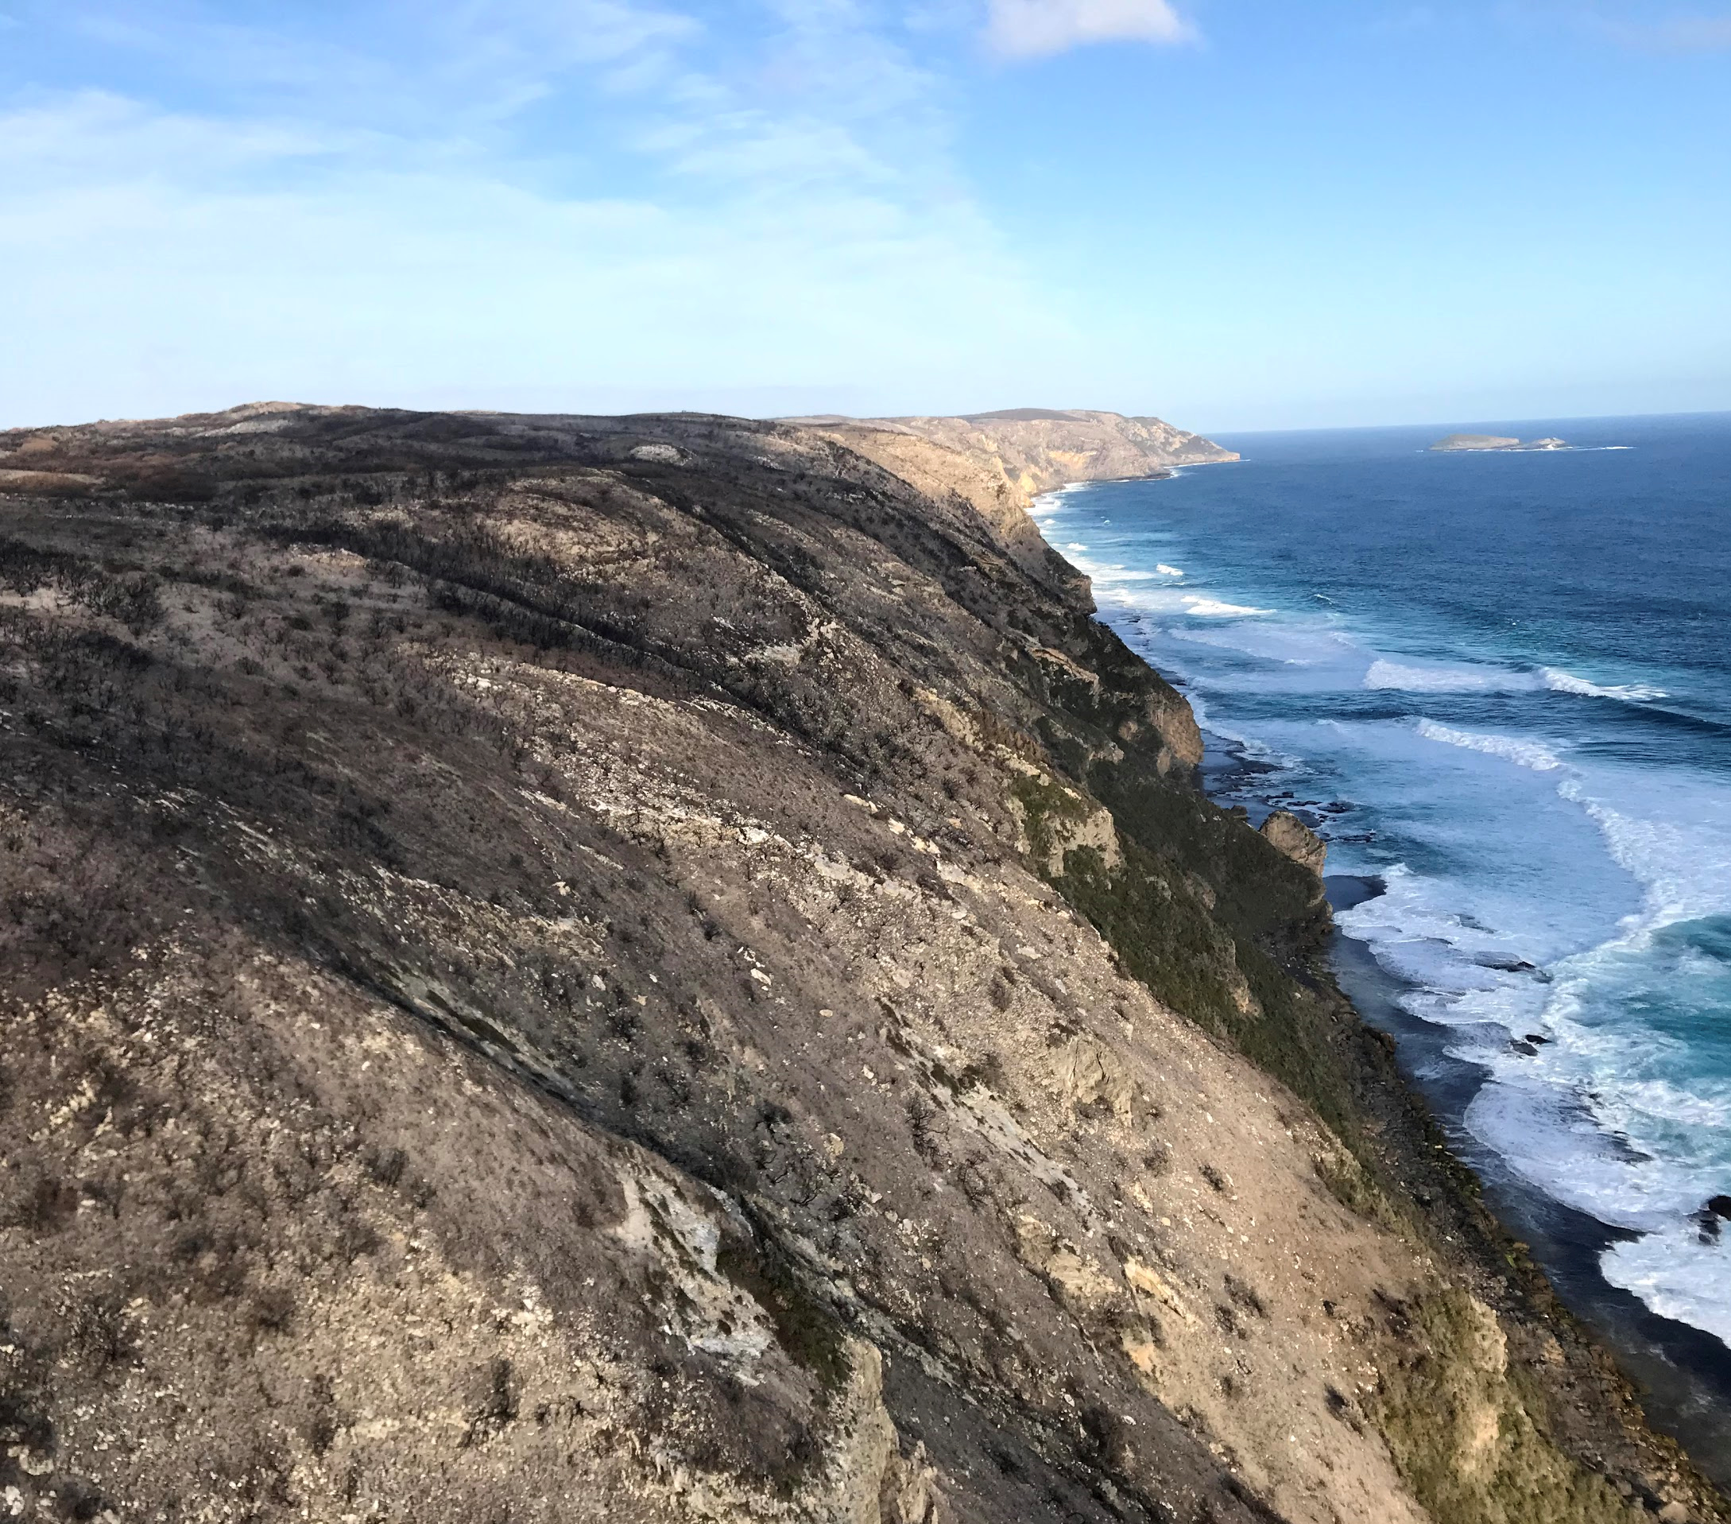 | 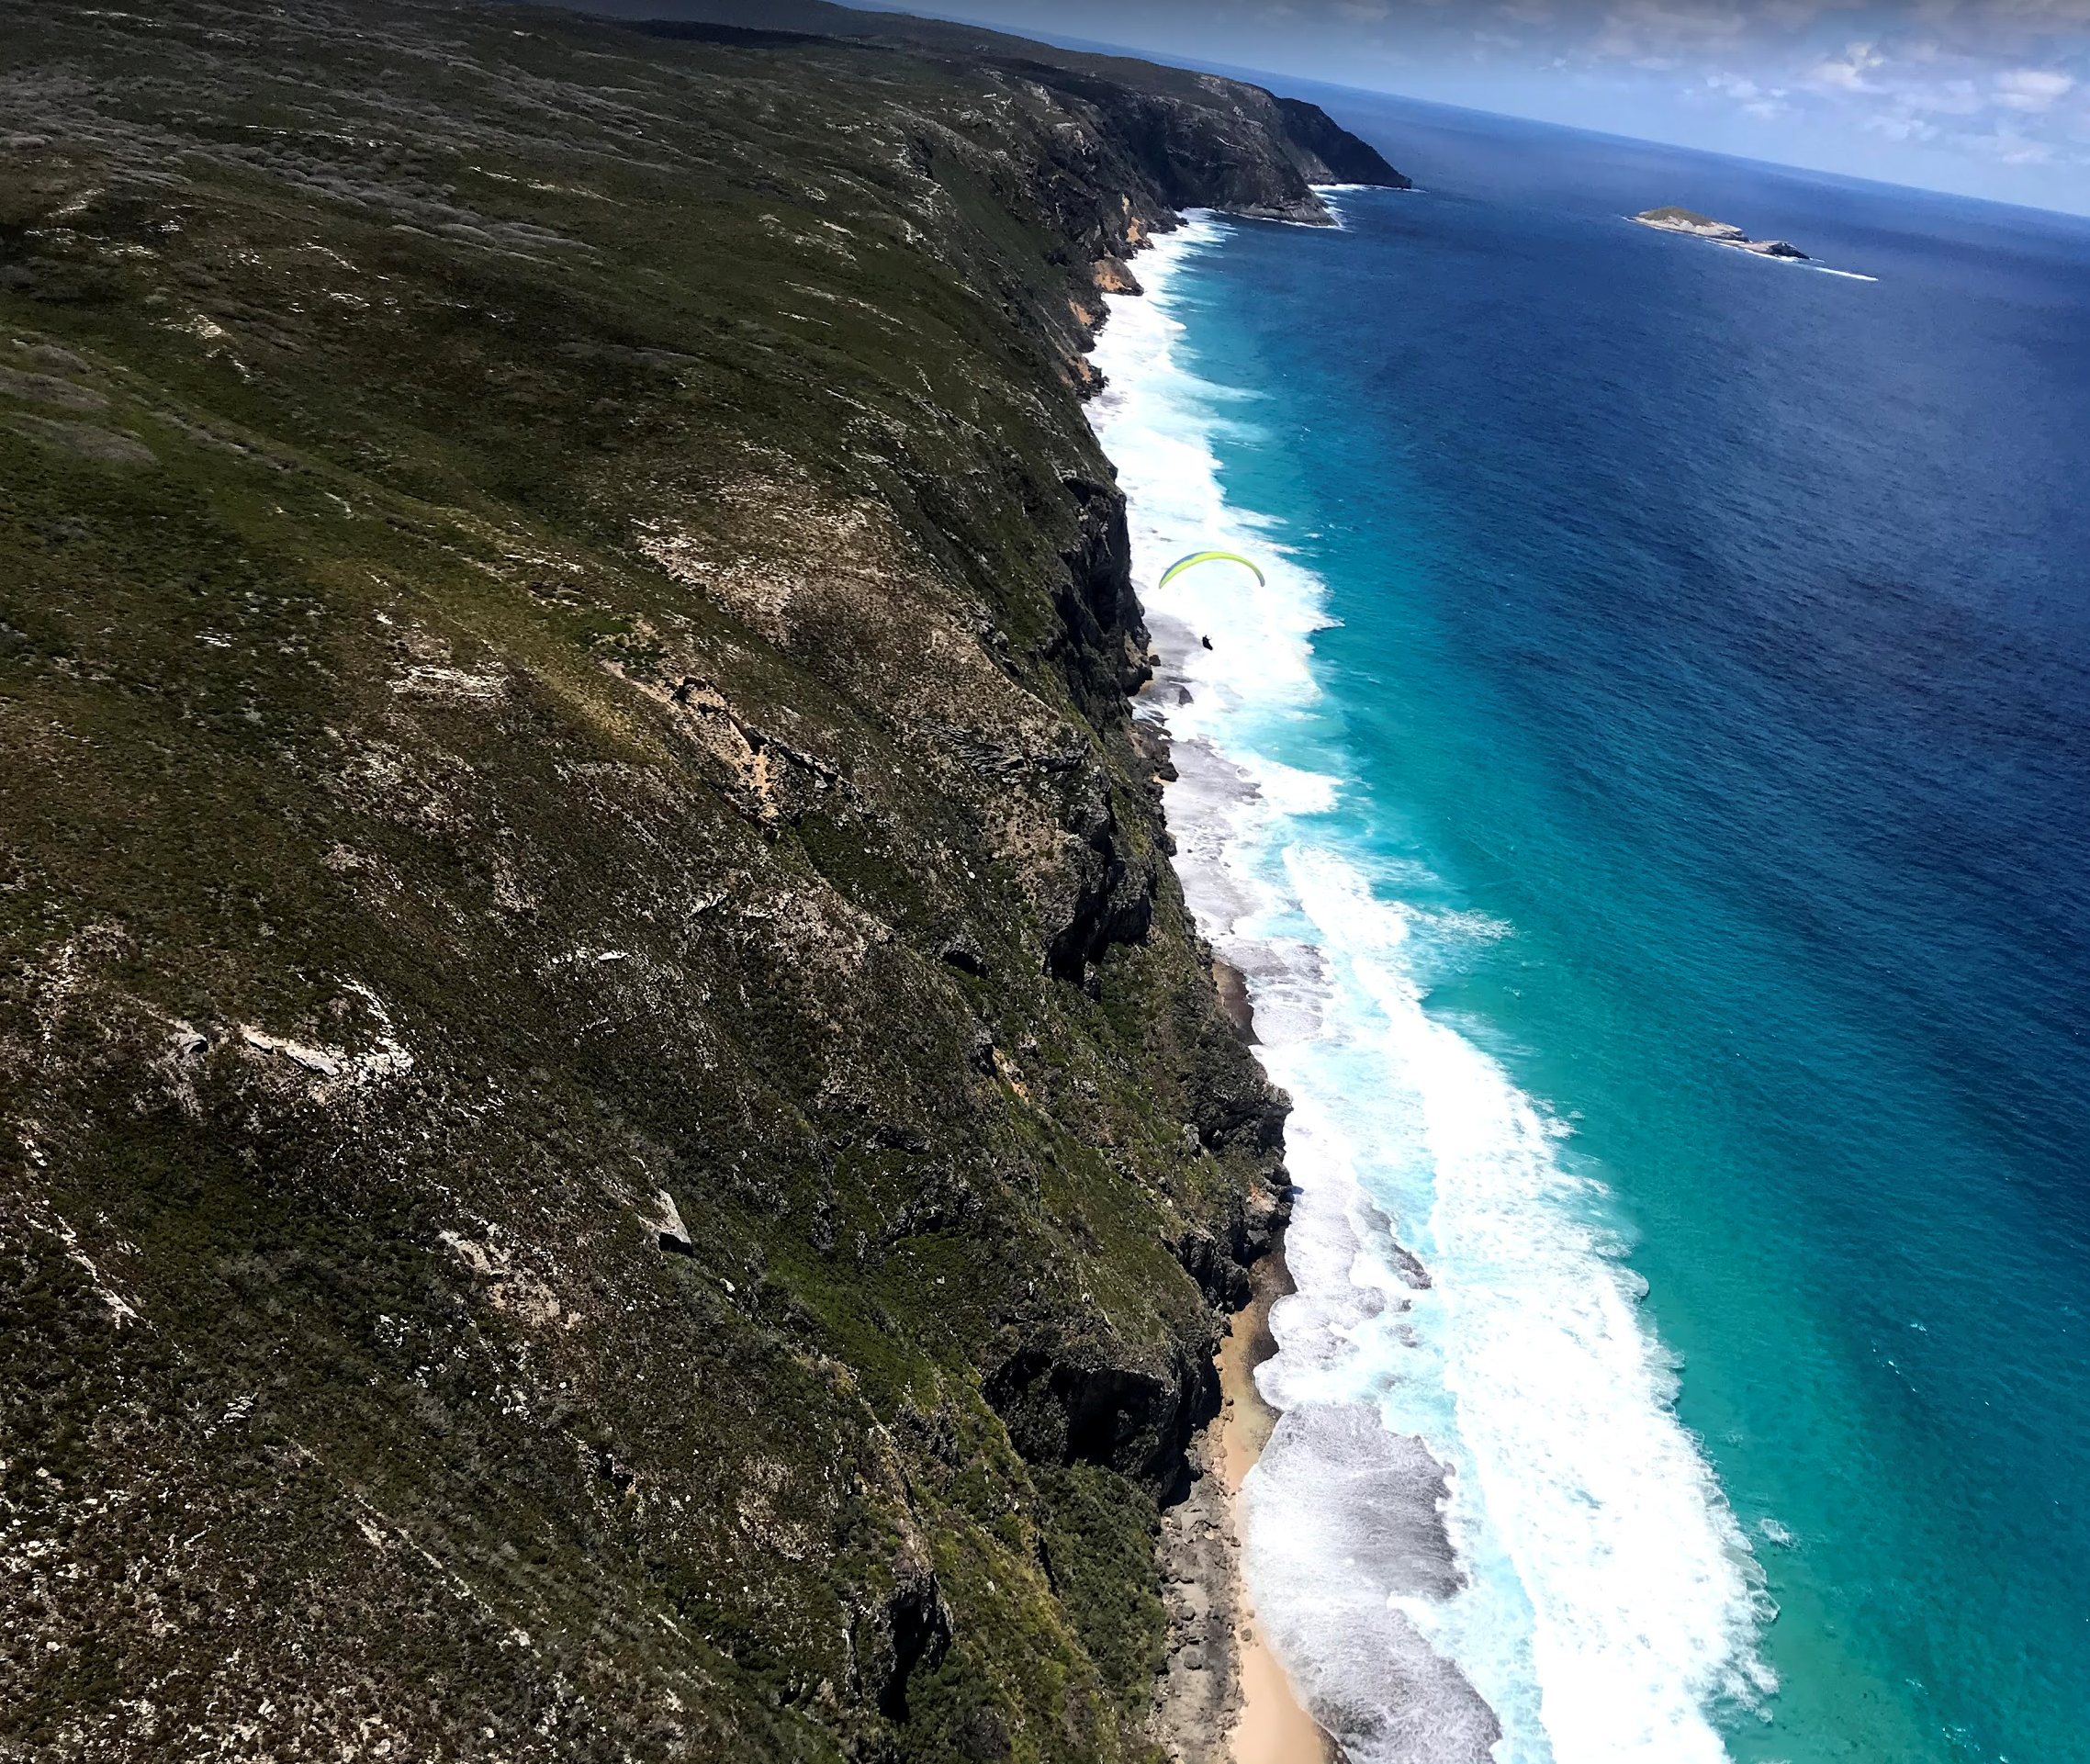
September 2018 | September 2020

- The photos show a fire affected section of Torndirrup National Park over a two-year period. In May 2018, a prescribed burn escaped into the park. Initially many flora species appeared to be lost from the area. With time, some species reappeared. The reappearance of lost flora was most likely due to

- revegetation strategies.
- primary succession.
- introduced species.
- secondary succession.

- Which of the following is not a function of the endoplasmic reticulum?
- Transportation of enzymes.
- Transportation of proteins.
- Digestion of proteins.
- Folding of proteins.

Questions 22 and 23 refer to the diagram and table shown below.

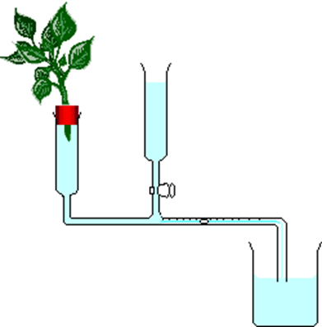

 | Time (minutes)
Environment | 2 | 4 | 6 | 8 | 10 | 12 | 14
 | Cumulative water loss (mL)
Humid | 0 | 0 | 0 | 0.8 | 1.6 | 2.2 | 2.7
Windy | 1.5 | 3.5 | 5.6 | 7.4 | 9.5 | 10.7 | 11.5
Intense light | 0.8 | 2.5 | 3.4 | 5.5 | 6.8 | 7.9 | 9.1
Normal classroom | 0 | 0 | 0.8 | 1.5 | 2.2 | 3.0 | 3.7

- The average rate of water used by the vegetation in humid conditions is

- 0.80mL.
- 7.30mL.
- 0.19 mL/minute.
- 1.82 mL/minute.

- Based on the data in the table above which of the following is suitable hypothesis?

- Humidity reduces transpiration in plants because humid air is already saturated with water vapour.
- Windy conditions increase the rate of transpiration in plants.
- A combination of intense light and wind gives the largest increase in plant transpiration.
- The humid conditions will show the least effect on plant transpiration.

- European Honeybees (Apis mellifera) were introduced to Australia from Europe in 1822. Their distribution throughout Australia has concerned biologists as they out-compete the 1,700 species of Australian native bees for the same floral resources and may disrupt pollination in native flora.

This will lead to reduced biodiversity at

- the genetic level.
- the species level.
- the ecosystem level.
- all levels.

- Phagocytes are a group of white blood cells that deactivate bacteria and other pathogens. They are essential in fighting infections. Phagocytes defeat pathogens by engulfing and subsequently digesting them using enzymes. The organelles directly responsible for digesting pathogens within the cytoplasm are

- lysosomes.
- ribosomes.
- golgi apparatus.
- mitochondria.

- A biologist wanted to estimate the density of Acacia aphylla in a 2000 m² study area. The biologist counted all individuals of the species in five quadrats. Each quadrat had an area of 100m². A total of fifteen individuals were found in the five quadrats. On the basis of these data, the best estimate of Acacia aphylla density in the study area is

- 60 plants.
- 75 plants.
- 0.03 plants/m².
- 0.15 plants/m².

- Spirogyra is a filamentous alga composed of cylindrical cells joined end to end, forming a strand. A biologist placed a 9.0cm long strand under a microscope and measured the length of several cells. The average cell length was 300um. The best estimate of the number of cells in the strand is

- 33.
- 300.
- 3000.
- 3300.

- Active transport is different to passive transport in that

- active transport occurs in animal cells but not in plant cells.
- passive transport requires a semi-permeable membrane.
- substances can only move against a diffusion gradient with passive transport.
- active transport requires energy to occur, passive transport does not.

- The first stage of the nitrogen cycle that allows that allows N₂ to be converted to nitrogenous compounds within the soil involves

- nitrogen-fixing bacteria.
- denitrifying bacteria.
- nitrifying bacteria.
- decomposers.

- The process of glycolysis

- requires oxygen to occur.
- uses 2 ATP molecules to form a glucose molecule.
- occurs in the mitochondria.
- converts glucose into pyruvate.

End of Section One

Section Two: Short answer 50% (100 Marks)

This section has five (5) questions. Answer all questions. Write your answers in the spaces provided in this Question/Answer booklet. Wherever possible, confine your answers to the line spaces provided. Use a blue or black pen for this section. Only graphs and diagrams may be drawn in pencil.

Additional working space pages at the end of this Question/Answer booklet are for planning or continuing an answer. If you use these pages, indicate at the original answer the page number it is planned/continued on and write the question number being planned/continued on the additional working space page.

Suggested working time: 90 minutes.

Question 31 (20 marks)

- List four properties common to all enzymes. (4 marks)

________________________________________________________________________________________________________________________________________________________________________________________________________________________________________________________________________________________

The flow chart below illustrates the action of a typical enzyme
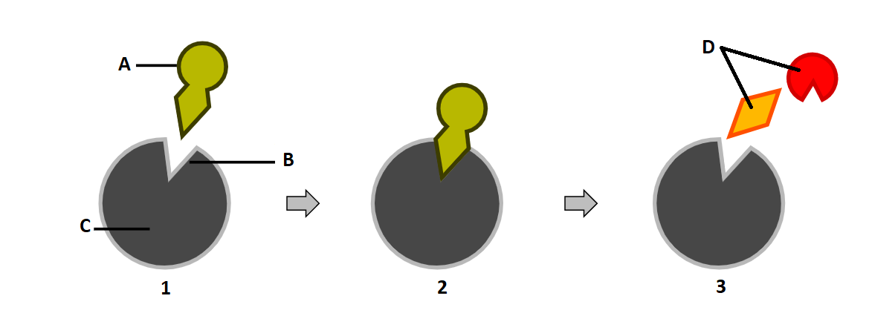

- Identify the structures on the diagram labelled: (4 marks)

A ____________________________________________________________________
B ____________________________________________________________________
C ____________________________________________________________________
D ____________________________________________________________________

- Two accepted models are used to explain the action of enzymes. Identify the model best represented by the diagram. Give reasons for your choice. (3 marks)

________________________________________________________________________________________________________________________________________________________________________________________________________________________________________________________________________________________

- Pepsin is an enzyme that breaks down proteins. It is produced in the stomach lining of carnivorous mammals. Explain why pepsin works efficiently in the stomach but slows in activity after leaving the stomach. (4 marks)

______________________________________________________________________________________________________________________________________________________________________________________________________________________________________________________________________________________________________________________________________________________________

- Describe the difference in structure between the digestive systems of ruminant animals
(such as cows and goats) and animals such as humans, dogs and pigs. (2 marks)

__________________________________________________________________________________________________________________________________________________________________________________________________________________

- Explain why the ruminant gut is suited to animals that have an herbivorous diet.
(3 marks)
______________________________________________________________________________________________________________________________________________________________________________________________________________________________________________________________________________________________________________________________________________________________

Question 32 (20 marks)

Dried meat baits (DMB) containing 1080 (sodium fluoroacetate) have traditionally been used by the Department of Agriculture and Food, Western Australia (DAFWA) to bait foxes. New fox baits known as Pro-baits were developed with the aim of reducing the amount of bait removal by invertebrates. Pro-baits have equal uptake by foxes as DMB.

Biologists placed four baits of each type into a conservation area. The baits were able to be accessed by invertebrates but were inaccessible to larger species. The results for the investigation are shown below.

 | Percentage of bait removed by invertebrates
Time (days) | DMB | Pro-bait
0 | 0 | 0
7 | 2 | 1
14 | 4 | 2
21 | 5 | 4
35 | 35 | 5
42 | 44 | 10

(a) Graph the percentage of DMB bait and Pro-bait removed against time.
. (6 marks)



A spare grid is at the end of this paper.
- Estimate the percentage of bait removed for DMB at

  - 28 days. (1 mark)

  - 49 days. (1 mark)

(c) In which estimate (28 days or 49 days) do you have the greater confidence? Give a reason for your answer. (2 marks)

(d) What is the independent variable in this study? Give a reason for your answer. (2 marks)

(e) State one way of improving the reliability of this investigation. (1 mark)

(f) Propose a hypothesis for this study. (2 marks)

- Identify three variables that were controlled by the biologists. (3 marks)

________________________________________________________________________________________________________________________________________________________________________________________________________________________________________________________________________________________

- Based on the results, which type of bait would be the most useful fox control? Give a reason for your choice. (2 marks)

__________________________________________________________________________________________________________________________________________________________________________________________________________________

Question 33 (20 marks)

(a) Name the anatomical structure of an earthworm that allows gas exchange between the internal and external environment. (1 mark)

(b) Define the term ‘spiracle’. (1 mark)

Identify two ways that the gas exchange system of a frog and bony fish are different. (2 marks)
____________________________________________________________________________________________________________________________________________________________________________________________________________________________________________________________________________________

- Identify two ways that the gas exchange system of a frog and bony fish are similar. (2 marks)
____________________________________________________________________________________________________________________________________________________________________________________________________________________________________________________________________________________

Give an example of an animal with a closed circulatory system. (1 mark)
____________________________________________________________________

- Give an example of an animal with an open circulatory system. (1 mark)
_____________________________________________________________________

- Describe two differences between open and closed circulatory systems. (4 marks)
_________________________________________________________________________________________________________________________________________________________________________________________________________________________________________________________________________________________________________________________________________________________

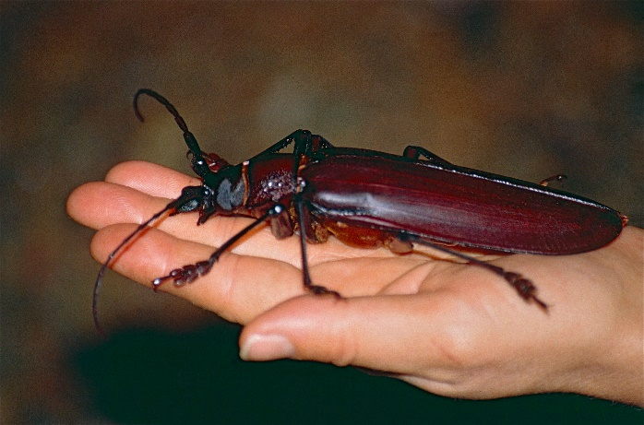

(e) The Titan Beetle (Titanus giganteus) is thought to be the largest of all insects, growing to over 16cm in length. Explain why insects are not able to grow to larger sizes. (4 marks)
____________________________________________________________________________________________________________________________________________________________________________________________________________________________________________________________________________________________________________________________________________________________________________________________________________________________________

- Explain how gas exchange in plants can be affected by their level of hydration.
(4 marks)
____________________________________________________________________________________________________________________________________________________________________________________________________________________________________________________________________________________________________________________________________________________________________________________________________________________________________

Question 34 (20 marks)

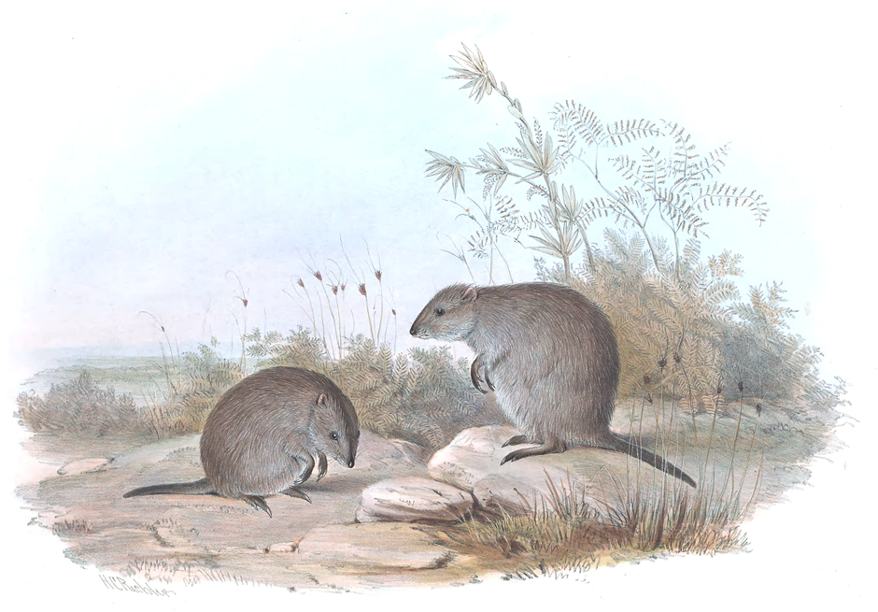

Gilbert's potoroo (Potorous gilbertii) is an endangered Australian marsupial. A 1000-hectare area near Albany holds the last native population of the species. Their habitat consists of very dense shrub within valleys of the reserve. Their diet consists primarily of a truffle-like fungi which is sensitive to drying climates. It is predicted that climate change will decrease the availability of truffles to the potoroo.

(a) Define the term ‘carrying capacity’. (2 marks)

__________________________________________________________________________________________________________________________________________________________________________________________________________________

- In 1841 Gilbert’s potoroos were often seen accompanied by quokkas. Based on this observation, some speculated both species had identical diets. Explain why this is unlikely. (2 marks)

________________________________________________________________________________________________________________________________________________________________________________________________________________________________________________________________________________________

- Describe the steps required to calculate an estimate of the Gilbert’s potoroo population using the capture-recapture method. (5 marks)

__________________________________________________________________________________________________________________________________________________________________________________________________________________________________________________________________________________________________________________________________________________________________________________________________________________________________________________________________________________________________________

(d) Identify and describe two conservation strategies that could be implemented to restore potoroo populations and their habitat. (4 marks)

(e) Explain why it is good practice to have more than one fertile male in an animal breeding program. (4 marks)

- Briefly describe the three strategies that form the basis of ethics guidelines in animal research. (3 marks)

______________________________________________________________________________________________________________________________________________________________________________________________________________________________________________________________________________________________________________________________________________________________________________________________________________________________
Question 35 (20 marks)

The diagram below represents the relationship between two different organelles found in the cells of all producers.

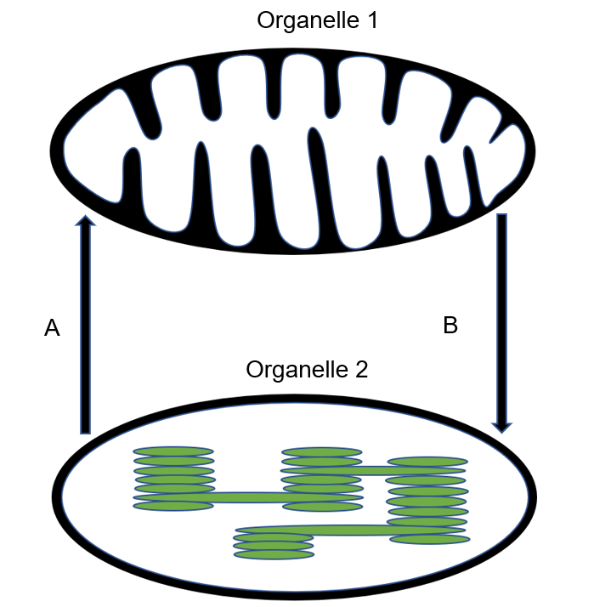
Structure 2
Structure 1

- Identify the name of: (4 marks)

- Organelle 1: _____________________________________________________
- Organelle 2: _____________________________________________________
- Structure 1: _____________________________________________________
- Structure 2: _____________________________________________________

- Arrows A and B indicate the exchange of substances between the two organelles. Name two substances represented by (4 marks)

- Arrow A: ______________________________________________________________________________________________________________________________
- Arrow B: ______________________________________________________________________________________________________________________________

(c) Identify the molecule that is known as the “molecular unit of currency” of energy transfer in organisms and describe two features of the molecule that make it ideal for this purpose. (3 marks)

(d) Complete the table below. (4 marks)
Stage of photosynthesis | Products | Where process occurs in chloroplast
Light dependent

Light independent

- With respect to metabolism explain the advantage of the folded and stacked membranes as illustrated in the diagram. How would a reduction in the folding of membranes affect the function of these organelles? (5 marks)

________________________________________________________________________________________________________________________________________________________________________________________________________________________________________________________________________________________________________________________________________________________________________________________________________________________________________________________________________________________________________________________________________________________________________________

End of Section Two

Section Three: Extended answer 20% (40 marks)

This section contains four (4) questions. You must answer two (2) questions; one (1) from Unit 1 and one (1) from Unit 2.

Use black or blue pen for this section. Only graphs and diagrams may be drawn in pencil. Responses can include: labelled diagrams with explanatory notes; lists of points with linking sentences; labelled tables and/or graphs; and/or annotated flow diagrams with introductory notes.

Additional working space pages at the end of this Question/Answer booklet are for planning or continuing an answer. If you use these pages, indicate at the original answer, the page number it is planned/continued on and write the question number being planned/continued on the additional working space page.

Suggested working time: 50 minutes

Unit 1

Choose either Question 36 or Question 37.

Indicate the question you will answer by ticking the box next to the question. Write your answer on pages 22 – 24. When you have answered your first question, turn to page 25 and indicate the second question you will answer on that page.

Question 36 (20 marks)

(a) Symbiotic relationships can be categorised into three types. Use examples to outline these three types and explain why collaboration is not categorised as a symbiotic relationship. (10 marks)
(b) Identify five human induced activities that can adversely affect biodiversity within ecosystems. Outline how each activity can lead to reduced biodiversity.
(10 marks)

OR

Question 37 (20 marks)

(a) Explain, with the aid of an annotated diagram, how carbon is cycled between the biotic and abiotic components of an ecosystem. (10 marks)
(b) All ecosystems can be divided into two major categories.
(i) Identify and describe the two categories
(ii) Identify two types of ecosystems within each major category. Discuss the abiotic and biotic factors particular to each of these ecosystems.
(10 marks)

Question number

Unit 2
Choose either Question 38 or Question 39.

Indicate the question you will answer by ticking the box next to the question. Write your answer on the pages provided.

Question 38 (20 marks)

(a) Organisms are formed from an array of complex structures which are composed of biological molecules (biomolecules). Discuss three of these biological molecules in terms of the monomers that compose them and their importance within organisms.
(10 marks)

(b) Explain the processes involved with moving water through a vascular plant starting from soil and ending at a stomate.
. (10 marks)

OR

Question 39 (20 marks)

(a) Both prokaryotic and eukaryotic cells possess plasma membranes.
(i) Describe the differences between the location of plasma membranes in prokaryotic and eukaryotic cells.
(ii) Describe the structure of the plasma membrane and the function of each of the components.
(10 marks)

(b) Explain, using well described examples, how the bodies of multicellular organisms are structured in a hierarchical fashion.
. (10 marks)

End of questions
Question number



Spare grid

